Business Consulting Start-Up Package and Fee Schedule
“Name” and “Business”
As of March 10, 2014

Remodel My Business, Inc. proposes the following Business Consulting Start-Up Package and fee schedule for Shawn McCadden’s consulting work and meeting facilitation activities on behalf of “Name” and “Business”.

Business Consulting/Coaching Start-Up Package
To get things started with new consulting clients, Remodel My Business, Inc. offers a flat fee Business Consulting Start-Up Package. This package includes a total of up to 10 hours of consulting and or coaching services provided by Shawn McCadden to all new clients at a fixed cost of $1750.00. During the included hours Shawn and “Name” will begin working together to identify, discuss, prioritize and then establish a critical path to help “Name” accomplish his business and or personal goals. To accept this arrangement and schedule our first interaction, “Name” can sign this agreement and return it to Shawn along with total payment of the Start-Up Package fee of $1750.00.

Hourly Consulting Retainer
After completion of the hours included in the Start-Up Package, “Name” and “Business” can provide payment against a retainer. The balance of funds in the retainer will be used to pay for hourly consulting time provided by Shawn McCadden on behalf of “Name” and “Business” Requests for consulting time by “Business” or others are to be at the direction of and/or are to be approved in advance by “Name”.

Billable hours will be charged at $175/hour against the retainer amount until the retainer amount is depleted. If the retainer balance is depleted, additional billable time will be charged at $205/hour until such time that the retainer balance is augmented. Payments will be recognized as of the postmark date of the payment. A retainer balance statement will be sent to “Name” on or about the last day of each month showing the retainer balance and hours billed against the retainer to date.

The rates described above apply to any service provided, whether given on-site, by telephone, fax, e-mail, or for the performance of a service requested by a client (example: asking me to research a particular topic). At this time there is no minimum billable time; if we talk on the phone for 10 minutes, you will be invoiced for 10 minutes.

When and if practical, some meetings may be conducted in person. Unless otherwise agreed to in advance, commuting time for Shawn McCadden will be billed for one half of the total travel time involved in a round trip.

After the initial flat fee Business Consulting Start-up fee, all funds received on account and applied to the retainer will remain the property of “Name” and “Business” Should “Name” decide for any reason to stop working with Shawn McCadden, any unused balance in the retainer will promptly be returned upon request by “Name”.

Expenses Related to Those Services Provided at Hourly Rates
Travel costs, if any, will be billed at actual cost:
- Lodging, flights, tolls, parking, etc will be billed at actual cost, with receipt copies provided.
- If a trip includes an over-night stay, meals will be accesses at a $45.00 per diem
- Mileage related to travel will be billed at $.60/mile

Late Appointments Related to Those Services Provided at Hourly Rates
If you have a scheduled phone consult or scheduled appointment, the clock begins at the designated start time. This means that if a one hour call is scheduled for 2:00 p.m. and you don’t call until 2:20 p.m., you will be charged from the original 2:00 start time. If my schedule permits me to accommodate a full hour with you (2:20 – 3:20 in this example), you will be charged for the total time (2:00 – 3:20 in this example). Clock time for site visits is considered to begin upon my arrival.

Cancellations Related to The Services Described Above:
I require advance notice of minimum one business day if you need to cancel a phone appointment, one week for an on-site visit or session. If you cancel less than one business day prior to a scheduled phone or on-site appointment time, you will be invoiced for one hour of consultation time at the same rates as defined in the Hourly Consulting Retainer section above. If you cancel a site visit that involves travel expenses (such as airfare or pre-paid hotel costs), you will be subject to the cost of any charges associated with cancellation.

If I need to cancel an appointment, I will provide advance notice of one business day at minimum. If I am unable to cancel with a minimum of one business day’s notice, I may make a reasonable effort to compensate you for any inconvenience. If I must cancel a site visit that involves travel expenses (such as airfare or pre-paid hotel costs), I will absorb the cost of any charges associated with cancellation.

NOTE:
Beginning July 1, 2014, rates are subject to change. If rates are to change, a new Fee Schedule will be provided prior to applying any increases.

Acceptance of Fee Schedule

Remodel My Business, Inc. will provide specific business consulting and coaching for “Business” at the rates defined and described above. Remodel My Business, Inc. will not be held responsible or liable for the actions of “Business” under any circumstance and does not represent “Business” or any company that “Business” owns or is affiliated with. By signing this agreement, “Business” enters into this agreement on their own will, with a clear and conscious mind and agrees to the terms and conditions described in this Agreement.

Signature of acceptance: __________________________ Title: ___________________

Date of acceptance: ____/____/____

Shawn McCadden CR, CLC
Remodel My Business, Inc.
President
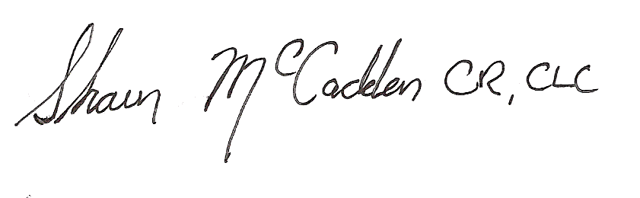
Date: 3/10/14

